Database Management System · Open-Ended Lab
Execution Outputs
CarGo Rentals · Syeda Khadija Hassan · Roll no. 2024-SE-09 · Software Engineering, University of Azad Jammu & Kashmir
Every figure below is the recorded result of running the exact SQL from CarGo_Rentals.sql against a live database (MariaDB 10.11, MySQL-compatible). The query is shown above each result. The grids are rendered from the real result sets returned by the server, so re-running the SQL file in MySQL Workbench, phpMyAdmin or the mysql client reproduces them.
Section | Contents
1 Database and sample data | Row counts, all five tables, constraint tests (Task 1)
2 Normalization check | Flat record R001 rebuilt from the normalized tables (Task 2)
3 JOIN queries | Queries 1 to 4 (Task 3)
4 View | vw_rental_report: definition and use (Task 4)
5 Triggers | Three triggers and rule-violation tests
6 Stored procedures | sp_register_rental and sp_return_vehicle: definition, life-cycle run, error tests (Task 6)
7 Optimization | EXPLAIN before / after on a 100,000-row copy (Task 7)
Section 1

Database and sample data (Task 1)
The database, five tables, keys and constraints are created by the first part of the SQL file. The sample data was then loaded and counted.
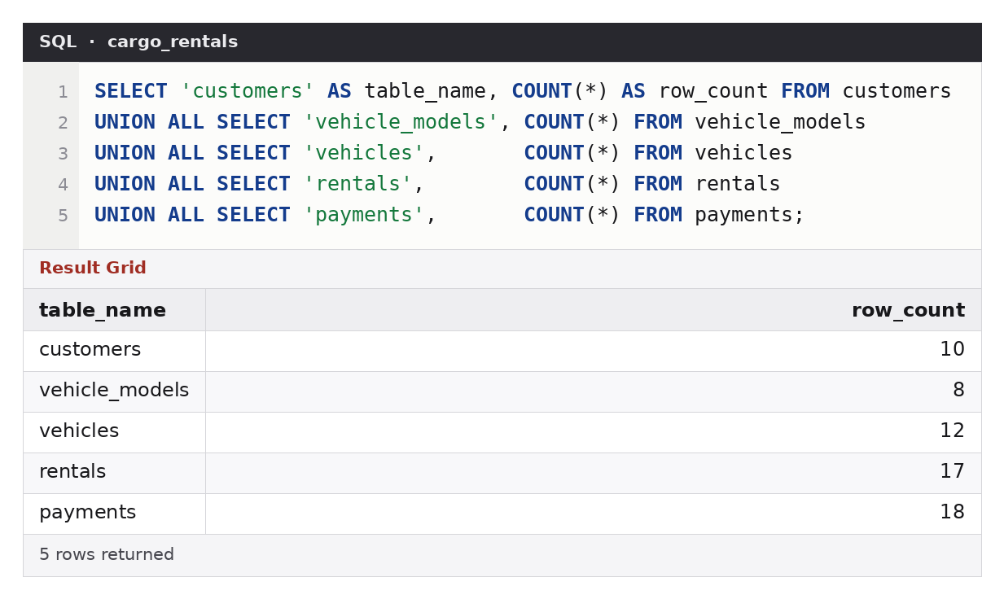
Figure 1 — Row counts after loading: 10 customers, 8 vehicle models, 12 vehicles, 17 rentals, 18 payments.
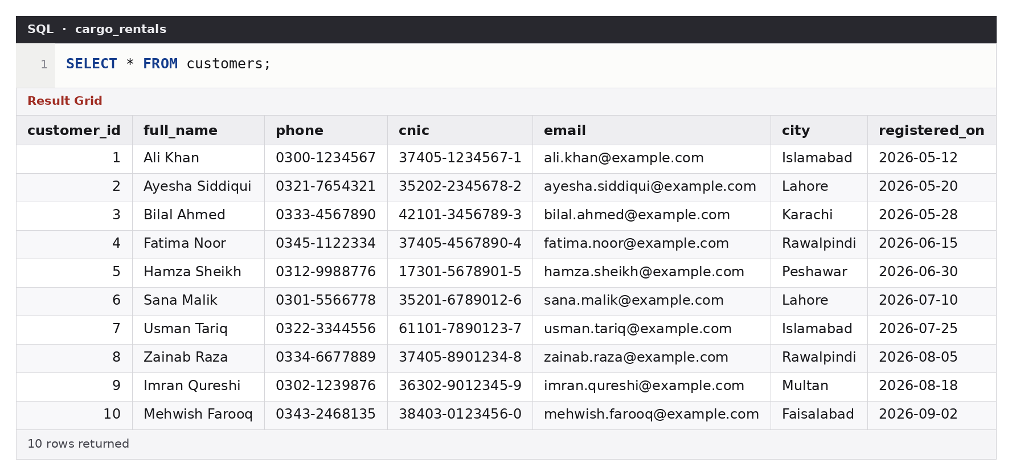
Figure 2 — Table customers.
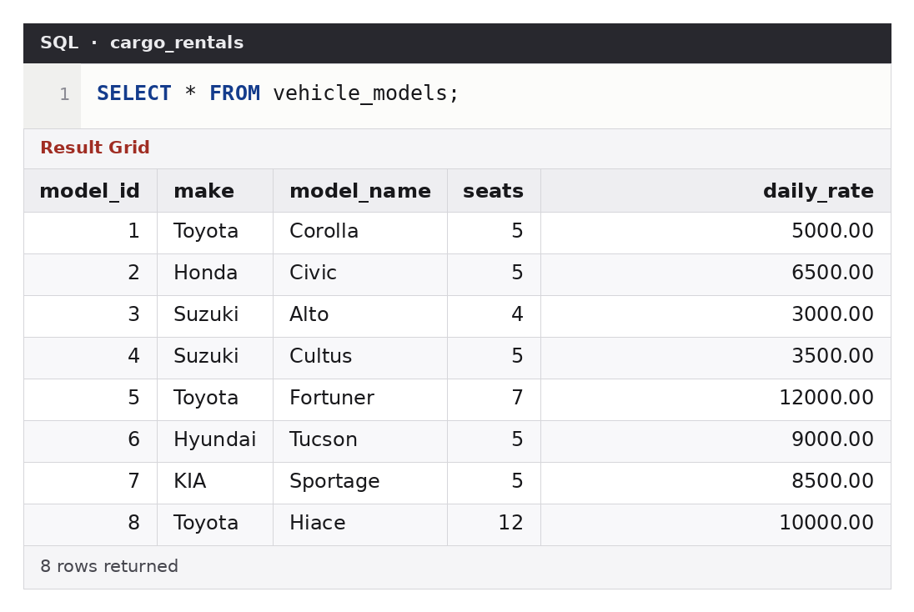
Figure 3 — Table vehicle_models (daily rate in PKR).
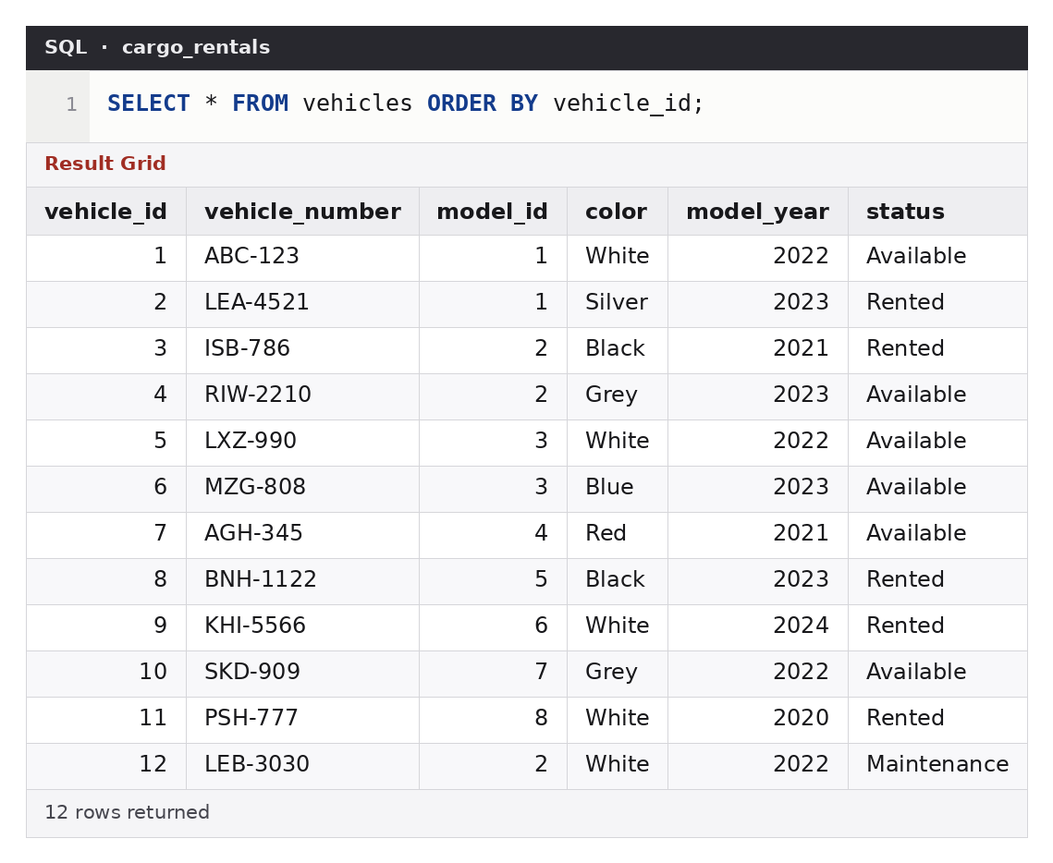
Figure 4 — Table vehicles. Five are Rented, one is in Maintenance, six are Available.
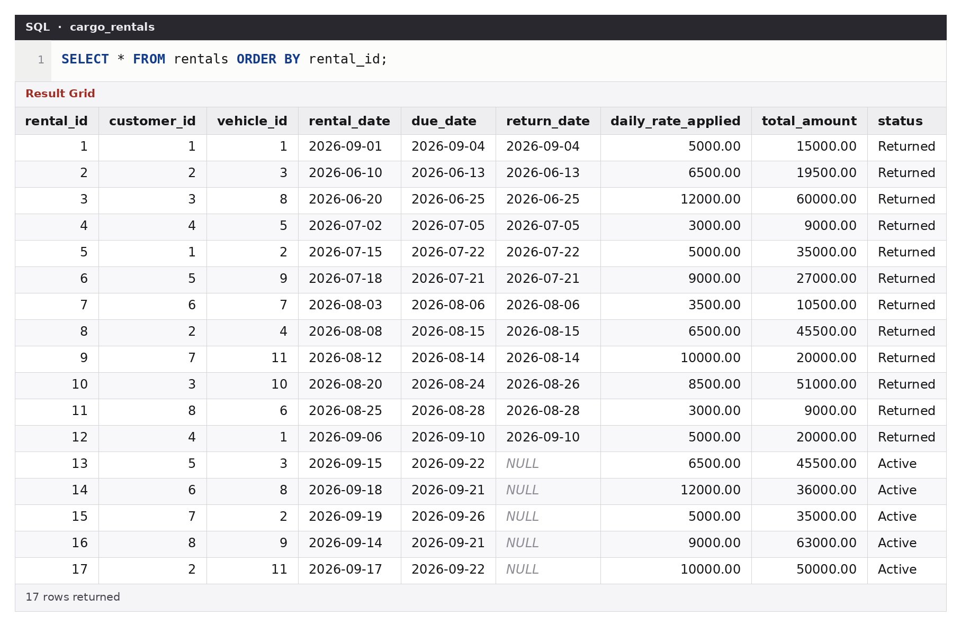
Figure 5 — Table rentals: 12 returned rentals (one returned two days late) and 5 active rentals with no return date.
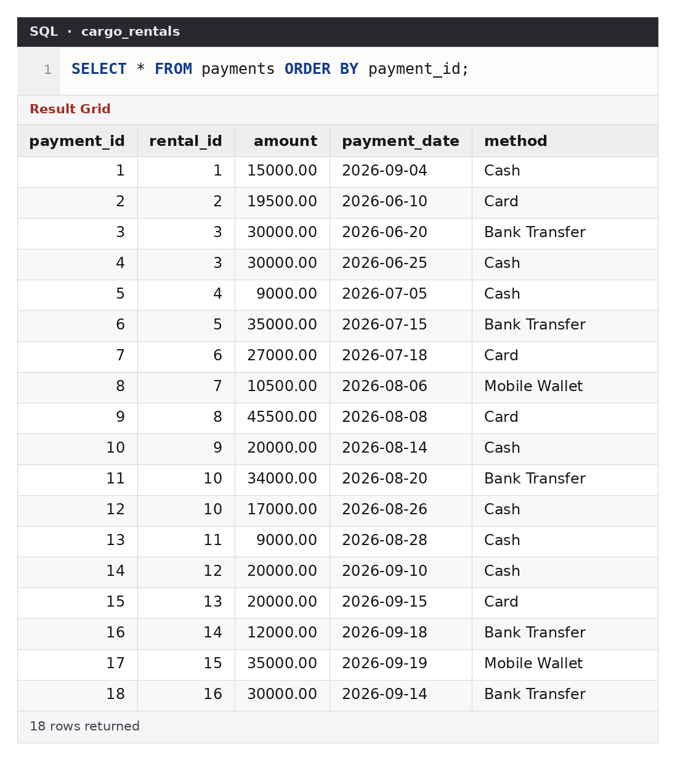
Figure 6 — Table payments: advance and balance payments, in cash, card, bank transfer and mobile wallet.
Constraint tests
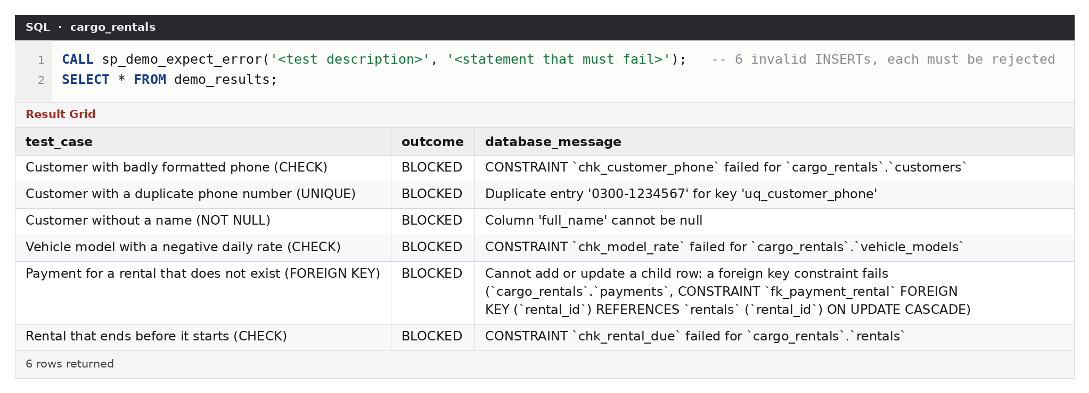
Figure 7 — Six invalid INSERTs, each rejected by the database: CHECK (phone format), UNIQUE (duplicate phone), NOT NULL, CHECK (negative rate), FOREIGN KEY (payment for a missing rental) and CHECK (due date before start).
Section 2

Normalization check (Task 2)
The handout’s flat record R001 is rebuilt by joining the normalized tables. The result matches the handout exactly, so the decomposition into 1NF, 2NF and 3NF lost no information.
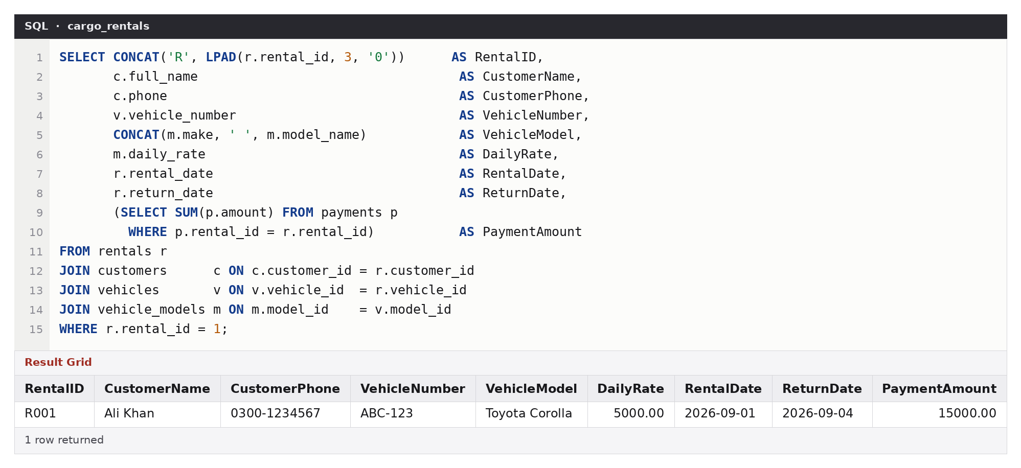
Figure 8 — Record R001 reconstructed from customers, vehicles, vehicle_models, rentals and payments.
Section 3

JOIN queries (Task 3)
Query 1: every rental with customer, vehicle, model and dates (INNER JOIN)
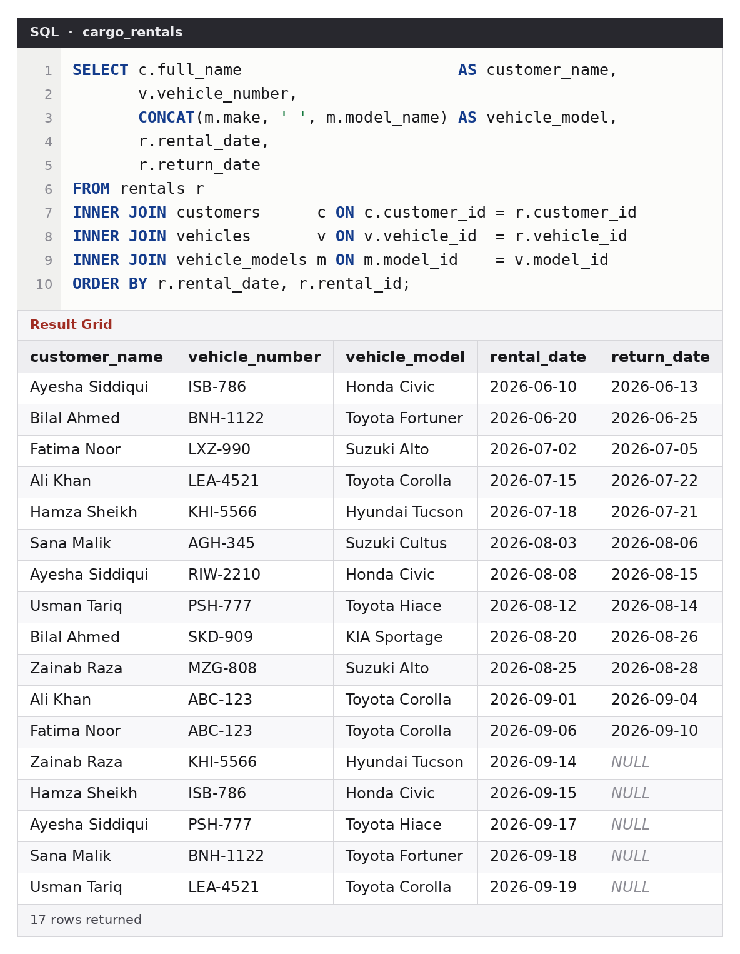
Figure 9 — All 17 rentals. return_date is NULL for the five vehicles that are still out.
Query 2: all customers and the vehicles they rented (LEFT JOIN from customers)
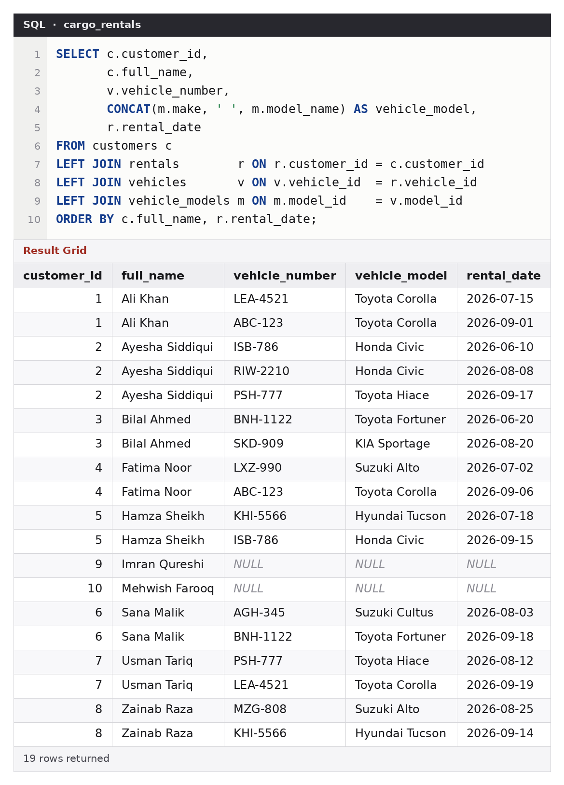
Figure 10 — 19 rows: 17 rentals plus Imran Qureshi and Mehwish Farooq, who never rented and therefore appear with NULLs.
Query 3: all vehicles with their current rental (LEFT JOIN from vehicles)
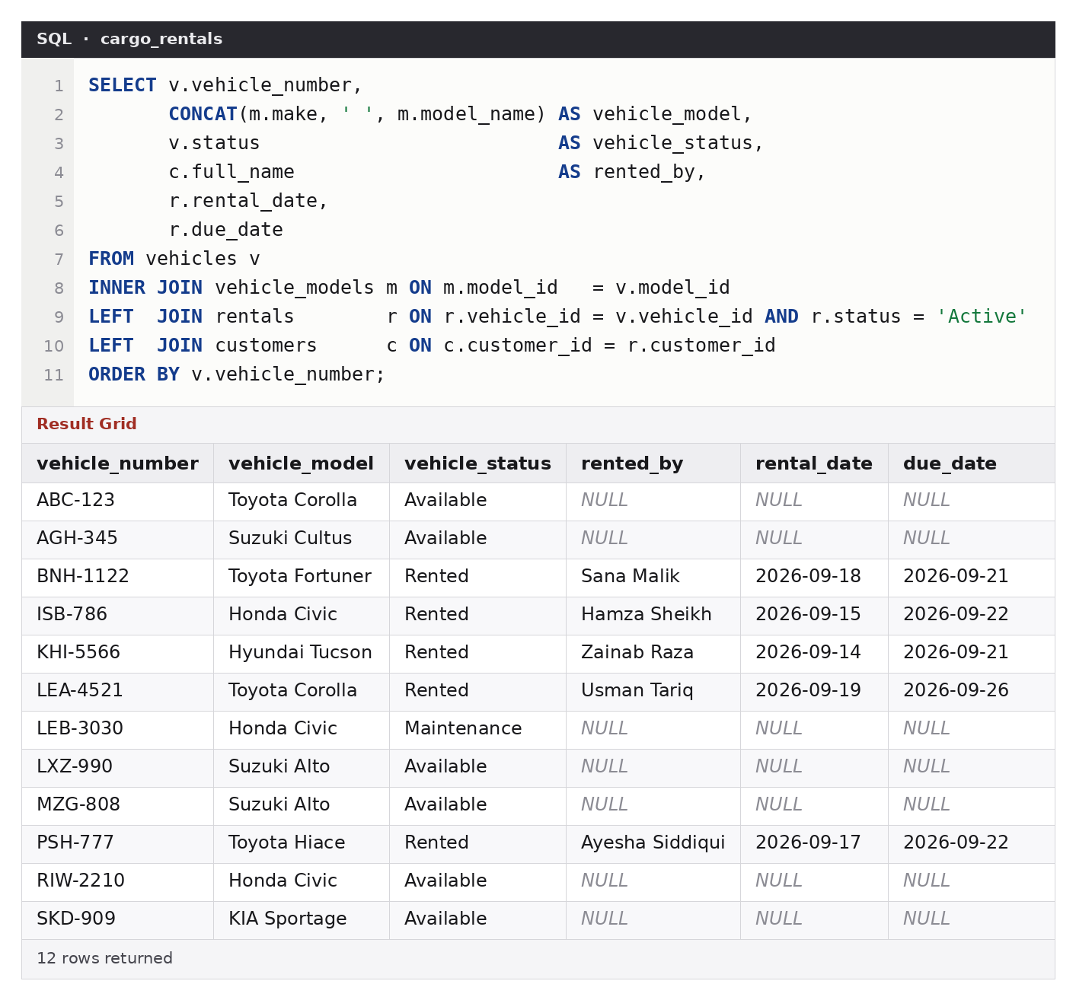
Figure 11 — All 12 vehicles. The “Active” filter is placed in the ON clause, not WHERE, so vehicles that are not rented still appear. Five are out with customer and dates; LEB-3030 is in maintenance.
Query 4: number of rentals per customer, including zero
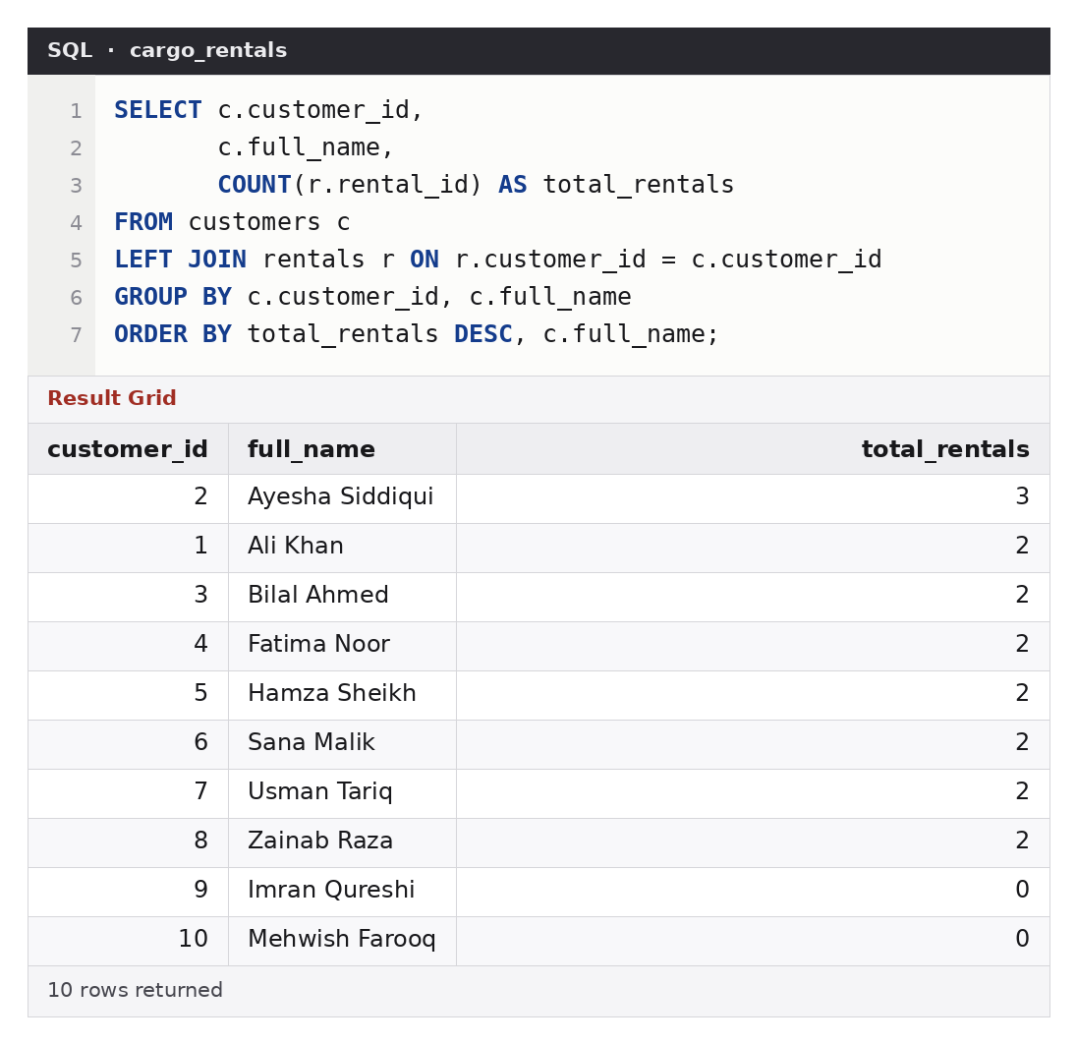
Figure 12 — COUNT(r.rental_id) counts real rentals only, so customers with none show 0 (COUNT(*) would wrongly show 1).
Section 4

View (Task 4)
vw_rental_report combines customer, vehicle, rental and payment information into one report. It is useful because staff and management read one ready-made report instead of rewriting a five-table join with a payment subtotal each time; it always gives consistent figures, and it can be filtered directly, for example to find rentals that still owe money.
CREATE OR REPLACE VIEW vw_rental_report AS
SELECT r.rental_id,
c.customer_id,
c.full_name AS customer_name,
c.phone AS customer_phone,
v.vehicle_number,
CONCAT(m.make, ' ', m.model_name) AS vehicle_model,
r.rental_date,
r.due_date,
r.return_date,
DATEDIFF(COALESCE(r.return_date, r.due_date), r.rental_date) AS rental_days,
r.daily_rate_applied,
r.total_amount,
COALESCE(p.paid, 0) AS amount_paid,
r.total_amount - COALESCE(p.paid, 0) AS balance_due,
CASE WHEN COALESCE(p.paid, 0) = 0 THEN 'Unpaid'
WHEN COALESCE(p.paid, 0) < r.total_amount THEN 'Partial'
ELSE 'Paid' END AS payment_status,
r.status AS rental_status
FROM rentals r
JOIN customers c ON c.customer_id = r.customer_id
JOIN vehicles v ON v.vehicle_id = r.vehicle_id
JOIN vehicle_models m ON m.model_id = v.model_id
LEFT JOIN (SELECT rental_id, SUM(amount) AS paid
FROM payments GROUP BY rental_id) p ON p.rental_id = r.rental_id;

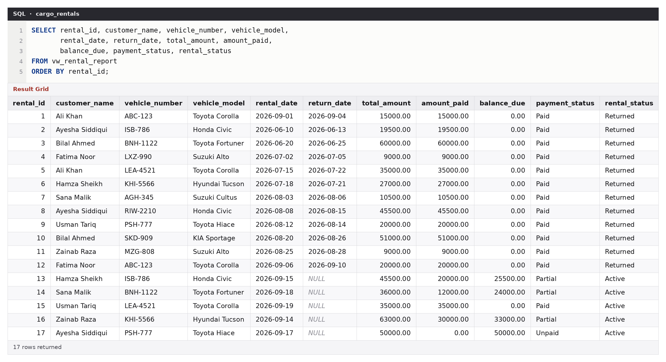
Figure 13 — SELECT from the view: every rental with total charge, amount paid, balance due, payment status and rental status.
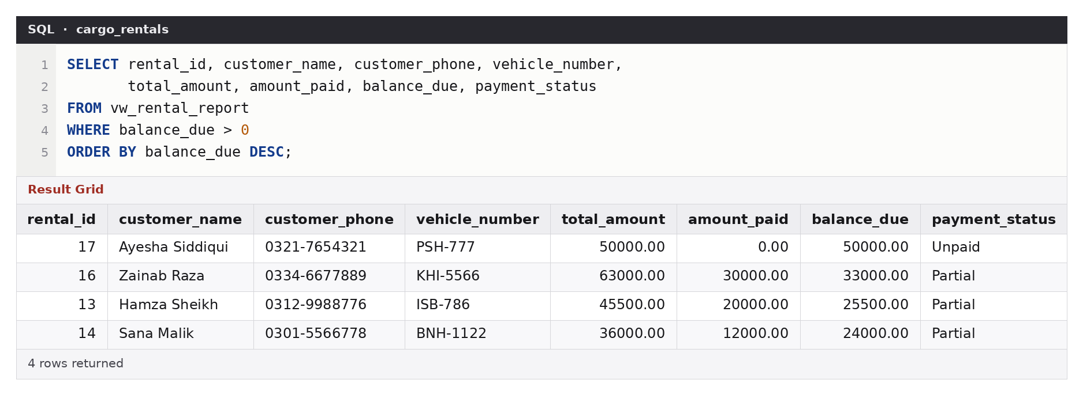
Figure 14 — The same view filtered with balance_due > 0: four active rentals still owe money, largest first.
Section 5

Triggers
The business rule is “a vehicle must not be available for another rental while it is already rented.” Three triggers on the rentals table enforce it.
trg_rentals_bi (BEFORE INSERT): reject invalid bookings
CREATE TRIGGER trg_rentals_bi
BEFORE INSERT ON rentals
FOR EACH ROW
BEGIN
DECLARE v_status VARCHAR(12);
DECLARE v_overlap INT DEFAULT 0;

SELECT status INTO v_status
FROM vehicles WHERE vehicle_id = NEW.vehicle_id;

IF NEW.status = 'Active' AND v_status <> 'Available' THEN
SIGNAL SQLSTATE '45000'
SET MESSAGE_TEXT = 'Vehicle is not available: it is already rented or under maintenance.';
END IF;

-- Date overlap with any other rental of the same vehicle
-- (a car may be handed over the same day the previous rental ends).
SELECT COUNT(*) INTO v_overlap
FROM rentals r
WHERE r.vehicle_id = NEW.vehicle_id
AND r.rental_date < COALESCE(NEW.return_date, NEW.due_date)
AND NEW.rental_date < COALESCE(r.return_date, r.due_date);

IF v_overlap > 0 THEN
SIGNAL SQLSTATE '45000'
SET MESSAGE_TEXT = 'Vehicle is already booked for an overlapping period.';
END IF;
END;
trg_rentals_ai (AFTER INSERT): mark the vehicle Rented
CREATE TRIGGER trg_rentals_ai
AFTER INSERT ON rentals
FOR EACH ROW
BEGIN
IF NEW.status = 'Active' THEN
UPDATE vehicles SET status = 'Rented' WHERE vehicle_id = NEW.vehicle_id;
END IF;
END;
trg_rentals_au (AFTER UPDATE): mark the vehicle Available on return
CREATE TRIGGER trg_rentals_au
AFTER UPDATE ON rentals
FOR EACH ROW
BEGIN
IF OLD.status = 'Active' AND NEW.status = 'Returned' THEN
UPDATE vehicles SET status = 'Available' WHERE vehicle_id = NEW.vehicle_id;
END IF;
END;

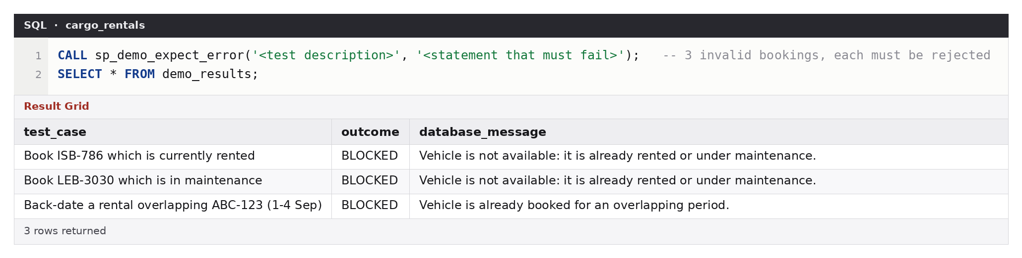
Figure 15 — Trigger tests on the raw rentals table: booking a car that is rented, booking a car in maintenance, and a back-dated rental that overlaps an existing one are all rejected with the trigger’s own message.
The positive case, where a trigger changes the vehicle status when a rental is created and returned, is shown in the life-cycle run in Section 6 (Figures 18 and 22).
Section 6

Stored procedures (Task 6)
sp_register_rental: register a rental and calculate the charge
CREATE PROCEDURE sp_register_rental (
IN p_customer_id INT UNSIGNED,
IN p_vehicle_number VARCHAR(10),
IN p_rental_date DATE,
IN p_days INT,
IN p_advance DECIMAL(12,2),
IN p_method VARCHAR(15),
OUT p_rental_id INT UNSIGNED,
OUT p_total DECIMAL(12,2)
)
BEGIN
DECLARE v_vehicle_id INT UNSIGNED;
DECLARE v_model_id INT UNSIGNED;
DECLARE v_status VARCHAR(12);
DECLARE v_rate DECIMAL(10,2);
DECLARE v_customer INT DEFAULT 0;

-- Any error: undo everything and pass the original error to the caller.
DECLARE EXIT HANDLER FOR SQLEXCEPTION
BEGIN
ROLLBACK;
RESIGNAL;
END;

SET p_rental_date = COALESCE(p_rental_date, CURRENT_DATE);
SET p_advance = COALESCE(p_advance, 0);
SET p_method = COALESCE(p_method, 'Cash');

IF p_days IS NULL OR p_days < 1 THEN
SIGNAL SQLSTATE '45000' SET MESSAGE_TEXT = 'Rental period must be at least 1 day.';
END IF;

START TRANSACTION;

SELECT COUNT(*) INTO v_customer FROM customers WHERE customer_id = p_customer_id;
IF v_customer = 0 THEN
SIGNAL SQLSTATE '45000' SET MESSAGE_TEXT = 'Customer not found.';
END IF;

-- Lock the vehicle row so two clerks cannot book the same car at once.
SELECT vehicle_id, model_id, status
INTO v_vehicle_id, v_model_id, v_status
FROM vehicles
WHERE vehicle_number = p_vehicle_number
FOR UPDATE;

IF v_vehicle_id IS NULL THEN
SIGNAL SQLSTATE '45000' SET MESSAGE_TEXT = 'Vehicle number not found.';
END IF;
IF v_status <> 'Available' THEN
SIGNAL SQLSTATE '45000' SET MESSAGE_TEXT = 'Vehicle is not available for rental.';
END IF;

SELECT daily_rate INTO v_rate FROM vehicle_models WHERE model_id = v_model_id;

SET p_total = v_rate * p_days;

IF p_advance < 0 OR p_advance > p_total THEN
SIGNAL SQLSTATE '45000'
SET MESSAGE_TEXT = 'Advance payment must be between 0 and the total charge.';
END IF;

INSERT INTO rentals
(customer_id, vehicle_id, rental_date, due_date, daily_rate_applied, total_amount)
VALUES
(p_customer_id, v_vehicle_id, p_rental_date,
DATE_ADD(p_rental_date, INTERVAL p_days DAY), v_rate, p_total);

SET p_rental_id = LAST_INSERT_ID();

IF p_advance > 0 THEN
INSERT INTO payments (rental_id, amount, payment_date, method)
VALUES (p_rental_id, p_advance, p_rental_date, p_method);
END IF;

COMMIT;
END;
sp_return_vehicle (bonus): return a car and adjust the charge if it is late
CREATE PROCEDURE sp_return_vehicle (
IN p_rental_id INT UNSIGNED,
IN p_return_date DATE,
OUT p_final_total DECIMAL(12,2)
)
BEGIN
DECLARE v_status VARCHAR(10);
DECLARE v_rental_date DATE;
DECLARE v_due_date DATE;
DECLARE v_rate DECIMAL(10,2);
DECLARE v_days INT;

DECLARE EXIT HANDLER FOR SQLEXCEPTION
BEGIN
ROLLBACK;
RESIGNAL;
END;

START TRANSACTION;

SELECT status, rental_date, due_date, daily_rate_applied
INTO v_status, v_rental_date, v_due_date, v_rate
FROM rentals
WHERE rental_id = p_rental_id
FOR UPDATE;

IF v_status IS NULL THEN
SIGNAL SQLSTATE '45000' SET MESSAGE_TEXT = 'Rental not found.';
END IF;
IF v_status = 'Returned' THEN
SIGNAL SQLSTATE '45000' SET MESSAGE_TEXT = 'This rental has already been returned.';
END IF;
IF p_return_date < v_rental_date THEN
SIGNAL SQLSTATE '45000' SET MESSAGE_TEXT = 'Return date cannot be before the rental date.';
END IF;

-- Agreed period is always charged; extra days (late return) cost the same daily rate.
SET v_days = GREATEST(DATEDIFF(v_due_date, v_rental_date),
DATEDIFF(p_return_date, v_rental_date));
SET p_final_total = v_days * v_rate;

UPDATE rentals
SET return_date = p_return_date,
status = 'Returned',
total_amount = p_final_total
WHERE rental_id = p_rental_id; -- trigger trg_rentals_au frees the vehicle

COMMIT;
END;

Life-cycle run
Step 1. Vehicle LXZ-990 (Suzuki Alto, 3,000 a day) is free.
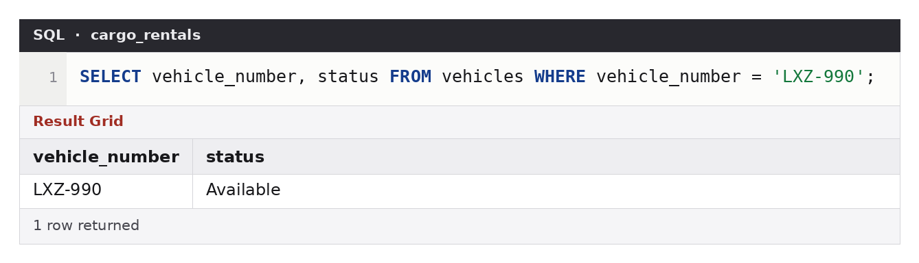
Figure 16 — Before: LXZ-990 is Available.
Step 2. Register a 4-day rental for customer 10 with a 6,000 advance. The procedure returns the new rental id and the calculated charge: 4 × 3,000 = 12,000.
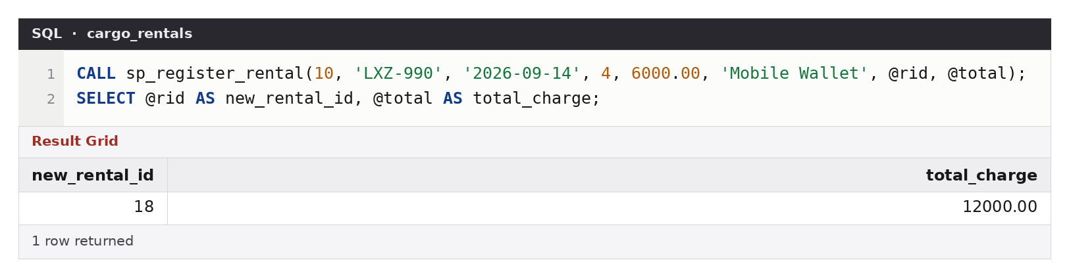
Figure 17 — Call to sp_register_rental with the two OUT parameters.
Step 3. The AFTER INSERT trigger has marked the vehicle Rented, and the view shows the rental with 6,000 still owing.
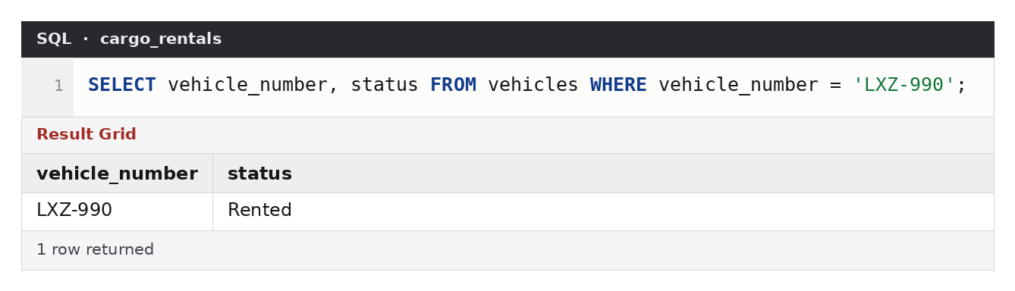
Figure 18 — After: LXZ-990 is Rented (set by trg_rentals_ai).
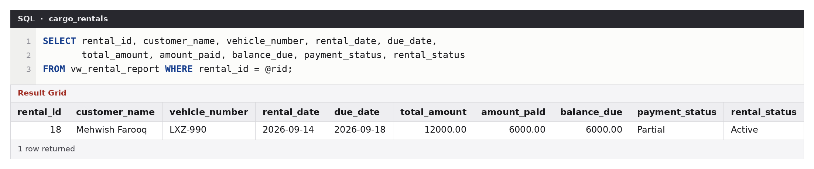
Figure 19 — The new rental in vw_rental_report: total 12,000, paid 6,000, balance 6,000, status Partial.
Step 4. Invalid calls are refused with a clear message, and nothing is written.
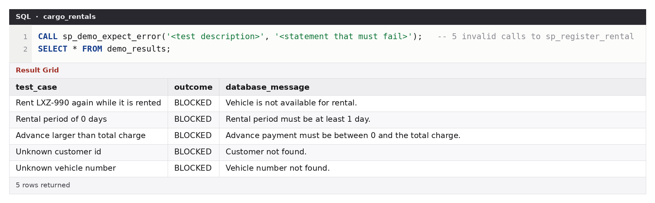
Figure 20 — Five invalid calls to sp_register_rental, all rejected: vehicle already rented, 0 days, advance larger than the charge, unknown customer, unknown vehicle.
Step 5. Return the car on 20 September; it was due on 18 September, so it is 2 days late. The charge becomes 6 days × 3,000 = 18,000.
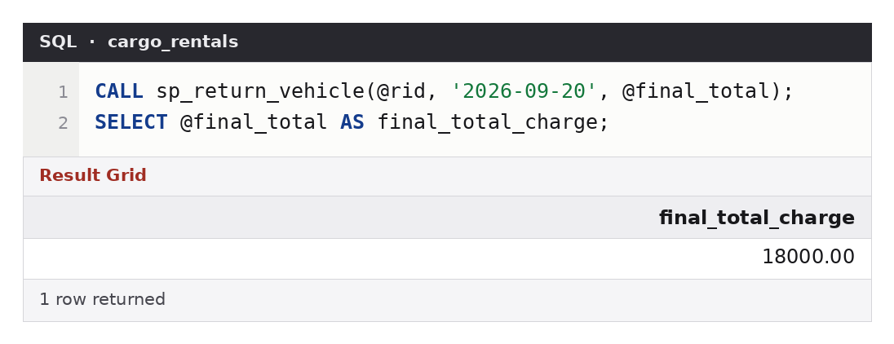
Figure 21 — Call to sp_return_vehicle with the recalculated total as an OUT parameter.
Figure 22 — After: LXZ-990 is Available again (set by trg_rentals_au).
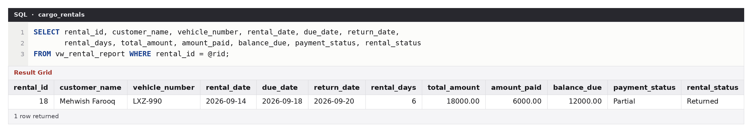
Figure 23 — The completed rental in the view: 6 days, total 18,000, paid 6,000, balance 12,000, status Returned.
Section 7

Optimization (Task 7)
Problem: the monthly activity report filters with YEAR(rental_date) and MONTH(rental_date). The functions on the column prevent any index from being used. A 100,000-row copy of the rentals table was generated to show the effect; the real tables were not touched.
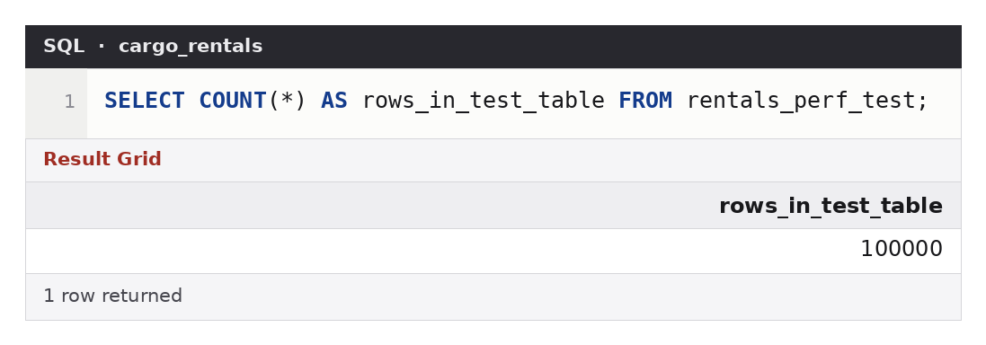
Figure 24 — The test copy holds 100,000 rentals.
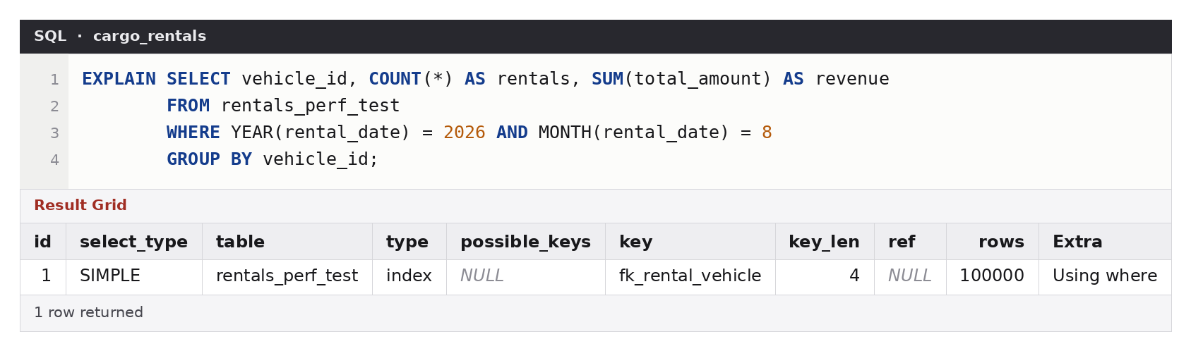
Figure 25 — BEFORE: function on the column, no index on rental_date. The optimizer estimates 100,000 rows read, which is the whole table.
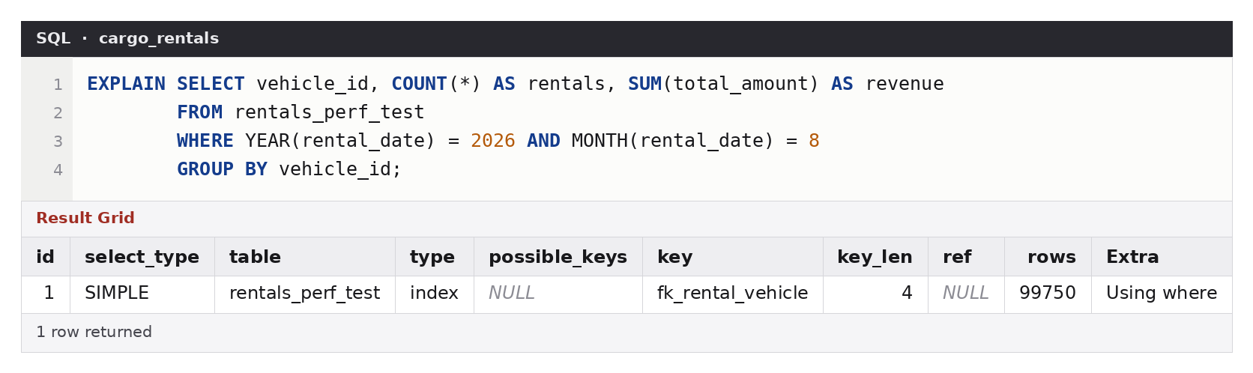
Figure 26 — Index added, same query: still about 99,750 rows read. The index is not used because of the functions.
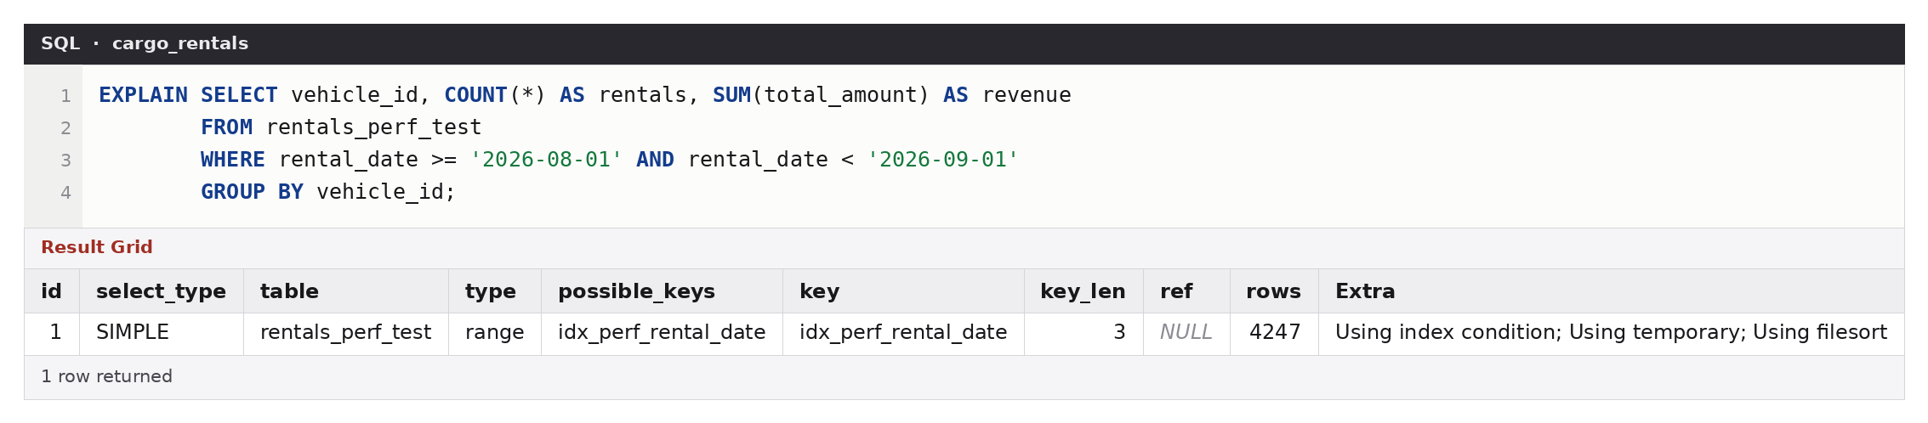
Figure 27 — AFTER: plain date range plus the index. type = range, key = idx_perf_rental_date, about 4,247 rows read.
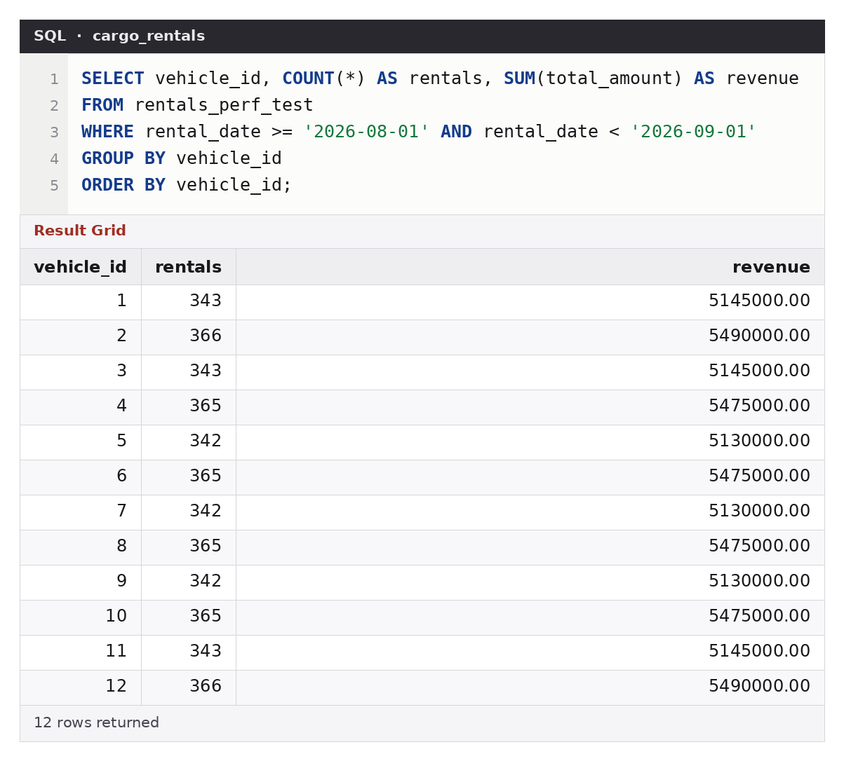
Figure 28 — The improved query returns the monthly figures for each vehicle (same answer as the original).
Measured median run time over 40 executions: about 79 ms before, 77 ms with only the index added, and 4.3 ms after the rewrite: roughly 18 times faster. Full discussion is in Section 5 of the report.

